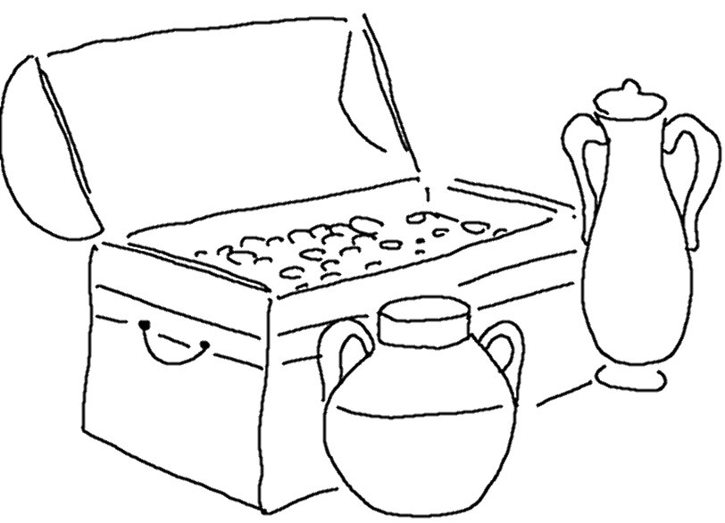
If you _ _ _ _ for me wholeheartedly, you will _ _ _ _ me. Jeremiah 29:13 _{NLT}

